Name: MARTINEZ JORDAN G
- Display all columns from tbl_employees.
- Display only the firstname and lastname of all employees.
- Show firstname, lastname, and salary of all employees.
- Find all employees whose firstname starts with 'S'.
- Find all employees whose lastname ends with 'off'.
- Find employees with firstname containing 'an'.
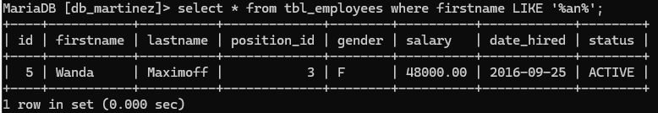
- Find employees whose firstname second letter is 'e'.
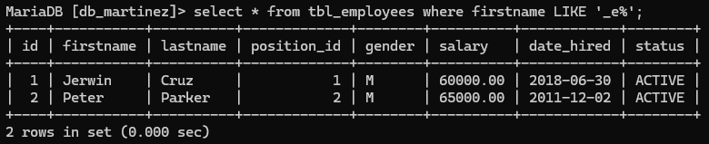
- Find employees whose lastname starts with 'R'.
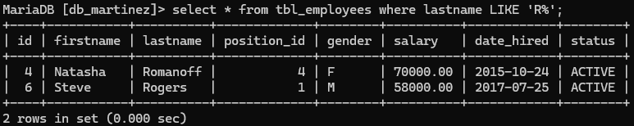
- Show distinct position_id values.
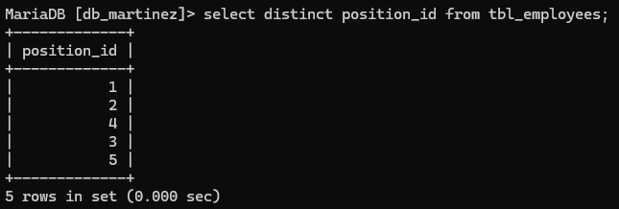
- Show distinct gender values from the table.
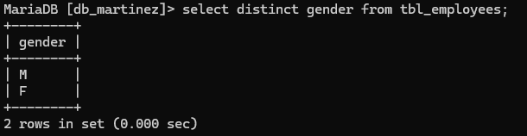
- Display all employees with a salary greater than 60,000.
- Display all employees who were hired before 2015-01-01.
- Display employees with gender = 'F'.
- Show employees whose status is ACTIVE.
- Display employees whose salary is between 50,000 and 70,000.
- Display employees sorted by firstname in ascending order.
- Display employees sorted by salary in descending order.
- Show employees sorted by date_hired (oldest first).
- Count how many employees are in each position_id.
- Count how many employees are grouped by gender.
- Find the total salary per position_id.
- Show position_id groups having more than 1 employee.
- Show gender groups where the average salary is above 60,000.
- Show only the first 3 employees from the table.
- Show 3 employees starting from the 3rd record in the table.

